 **OUTREACH SCHOOLS EXAMINATIONS BOARD**

**MID TERM I EXAMINATION 2023**

**PRIMARY ONE**

**MATHEMATICS**

**Name: ___________________________________________**

**School: ____________________________________________**

**SECTION A (20mks)**

1. **Add:**
2. 2 + 2 = ______
3. 1 + 3 + 2 = _____
4. 8 + 1 = _____
5. 2 + 3 = ______
6. **Fill in the missing numbers.**

1, ______, 3, ______, _______, 6, 8, ______, 10.

1. **Name these shapes.**

____________________ ____________________ ____________________

**(circle, rectangle, square, triangle, oval)**

1. **Circle the smaller number.**
2. 2 and 6
3. 8 and 5
4. 10 and 01
5. 16 and 20
6. **Match correctly.**

1 ten

6 two

2 one

10 six

1. **Take away.**
2. 8 - 2 = ________
3. 10 - 3 = _______
4. 9 - 4 = ______

**SECTION B**

1. 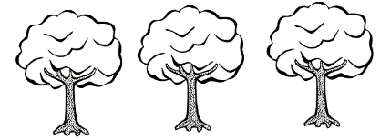 **Count and write the number.**
2. 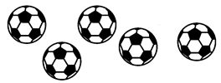 =
3. 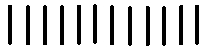 =
4. 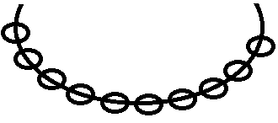 =
5. =
6. **Write the number before.**
7. __________, 8
8. __________, 16
9. __________, 11
10. **Shade for the given number.**
11. = 4
12. = 2
13. = 5
14. **Form new sets.**

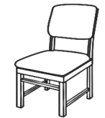



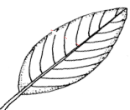

1. **Count members in the sets.**

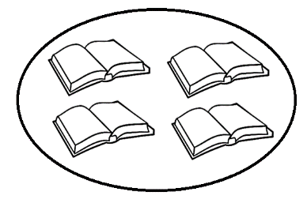

1. A set of ____________________ books.

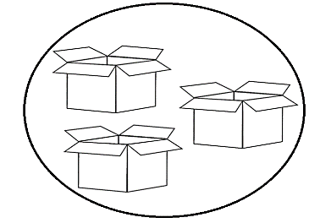

1. A set of ___________________ boxes.

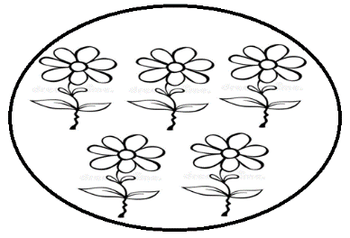

1. A set of ___________________ flowers.
2. **Write the number name.**
3. 2 ____________________
4. 12 ____________________
5. 6 ___________________
6. 20 ___________________
7. **Show the working.**
8. Eight take away three is ________________

8 - 3 = _______

1. Four plus two is _______________
2. Seven plus one is _________________
3. How many eyes do you have?

_____________________________________

1. 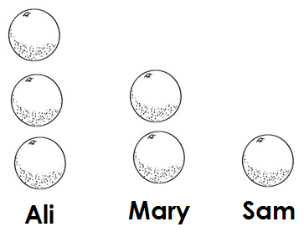**These children have oranges.**
2. Ali has ____________________ oranges.
3. Mary has _____________________ oranges.
4. Who has one orange? ___________________________________
5. How many oranges do they have altogether?

_________________________________________________________

**END**